**Multi Client-Server Chat**

INTRODUCTION

A multi-client server chat system is a communication framework where multiple clients can connect and communicate with a central server simultaneously. This type of system is often used in real-time communication applications like chatrooms, customer support platforms, and collaborative workspaces. The server manages the connections, message routing, and ensures that all clients can communicate effectively, even if they are not directly connected to each other.

In an era where digital communication is fundamental to personal and professional interactions, the need for robust, real-time messaging systems has never been greater. The Multi-Client Server Chat Project addresses this need by creating a sophisticated chat system that supports multiple users interacting simultaneously through a central server.

This project aims to build a scalable and secure chat platform that allows users to exchange messages instantly and reliably. The system is designed to handle multiple client connections, ensuring seamless communication across diverse network conditions. By integrating advanced features such as real-time message delivery, encryption, and user management, the chat system is poised to meet the demands of modern communication environments.

**SOURCE CODE**

1. SERVER CODE:

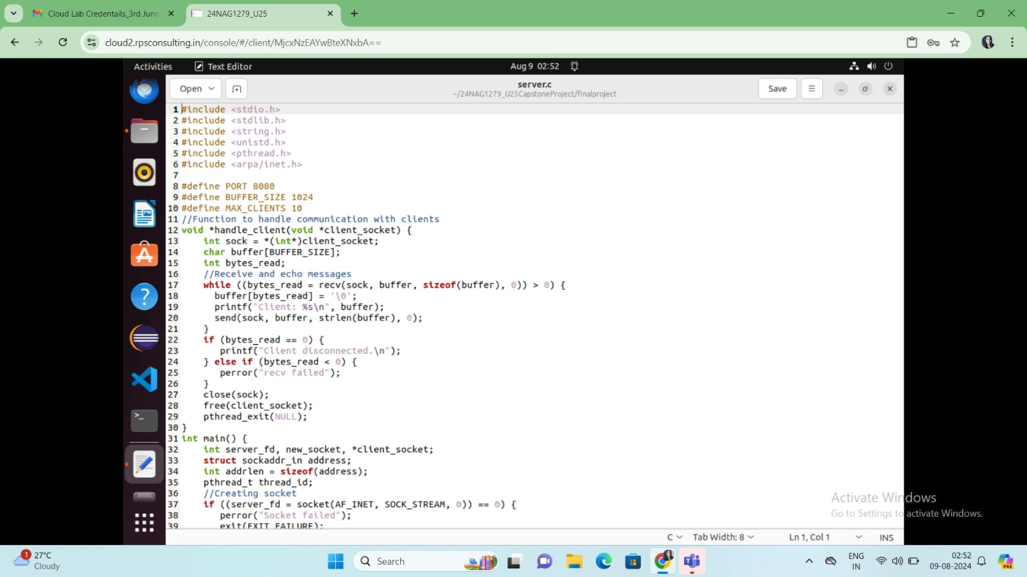

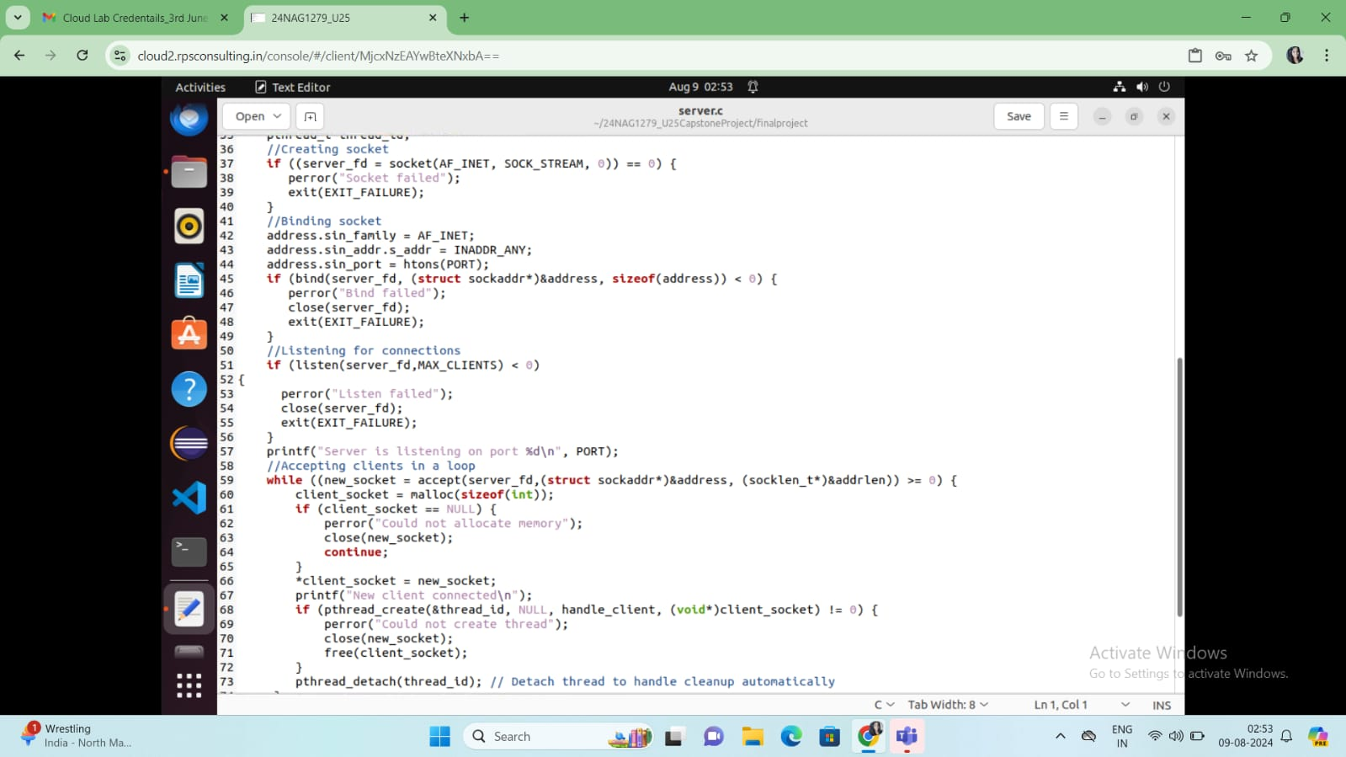

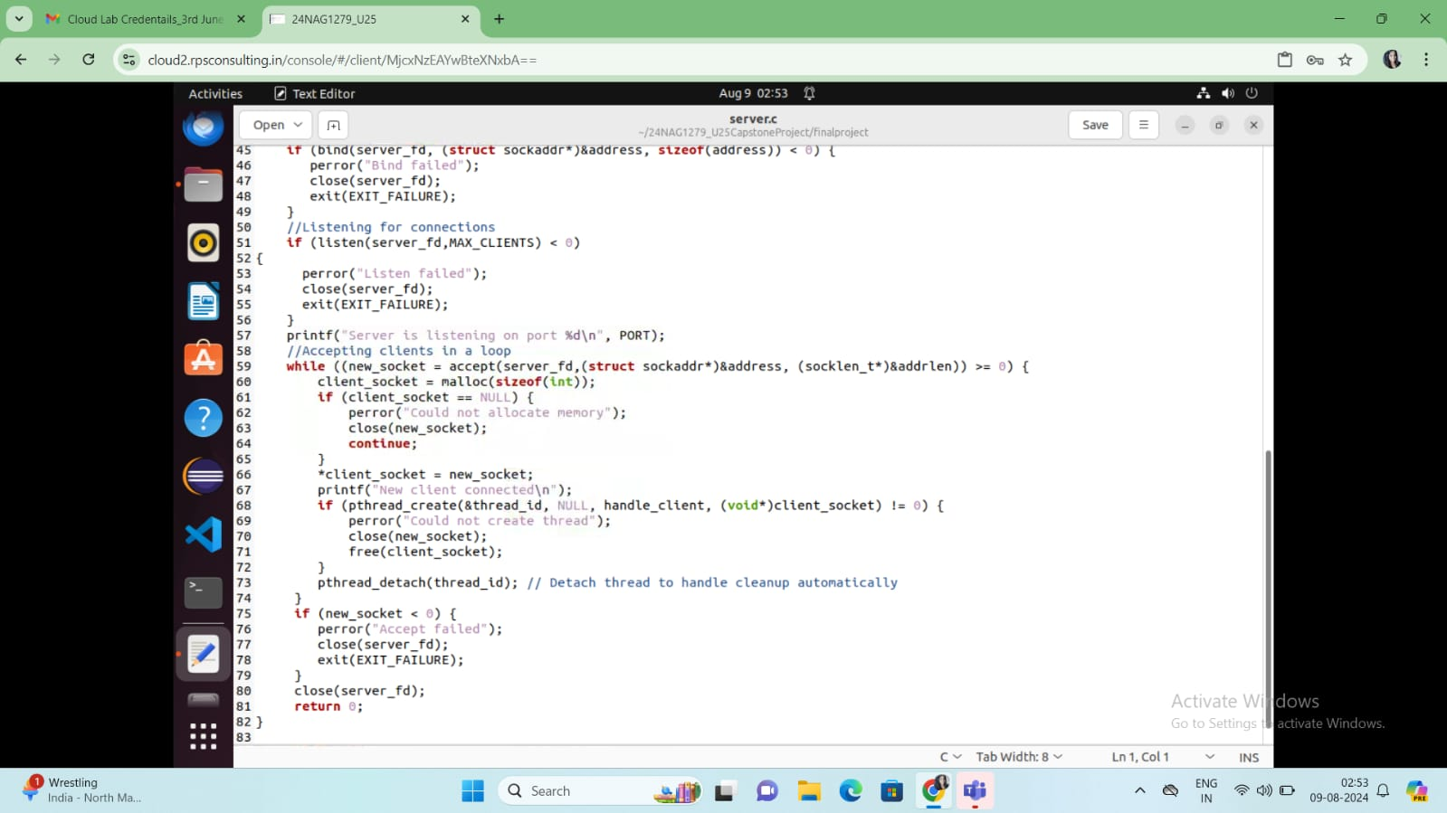

1. CLIENT CODE:

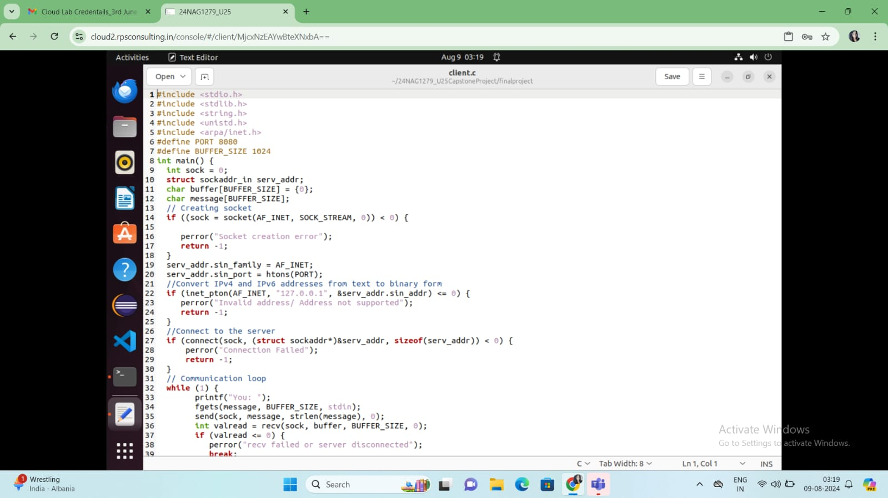

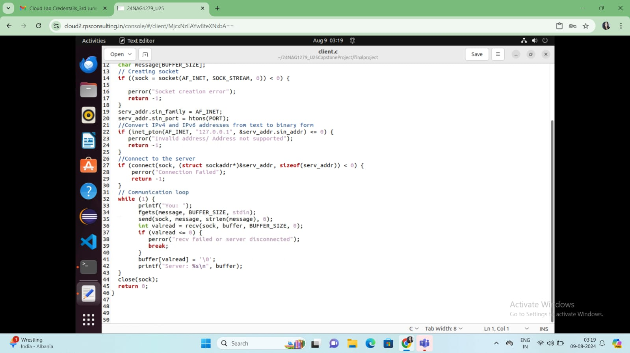

**OUTPUTS**

1. SERVER OUTPUT:

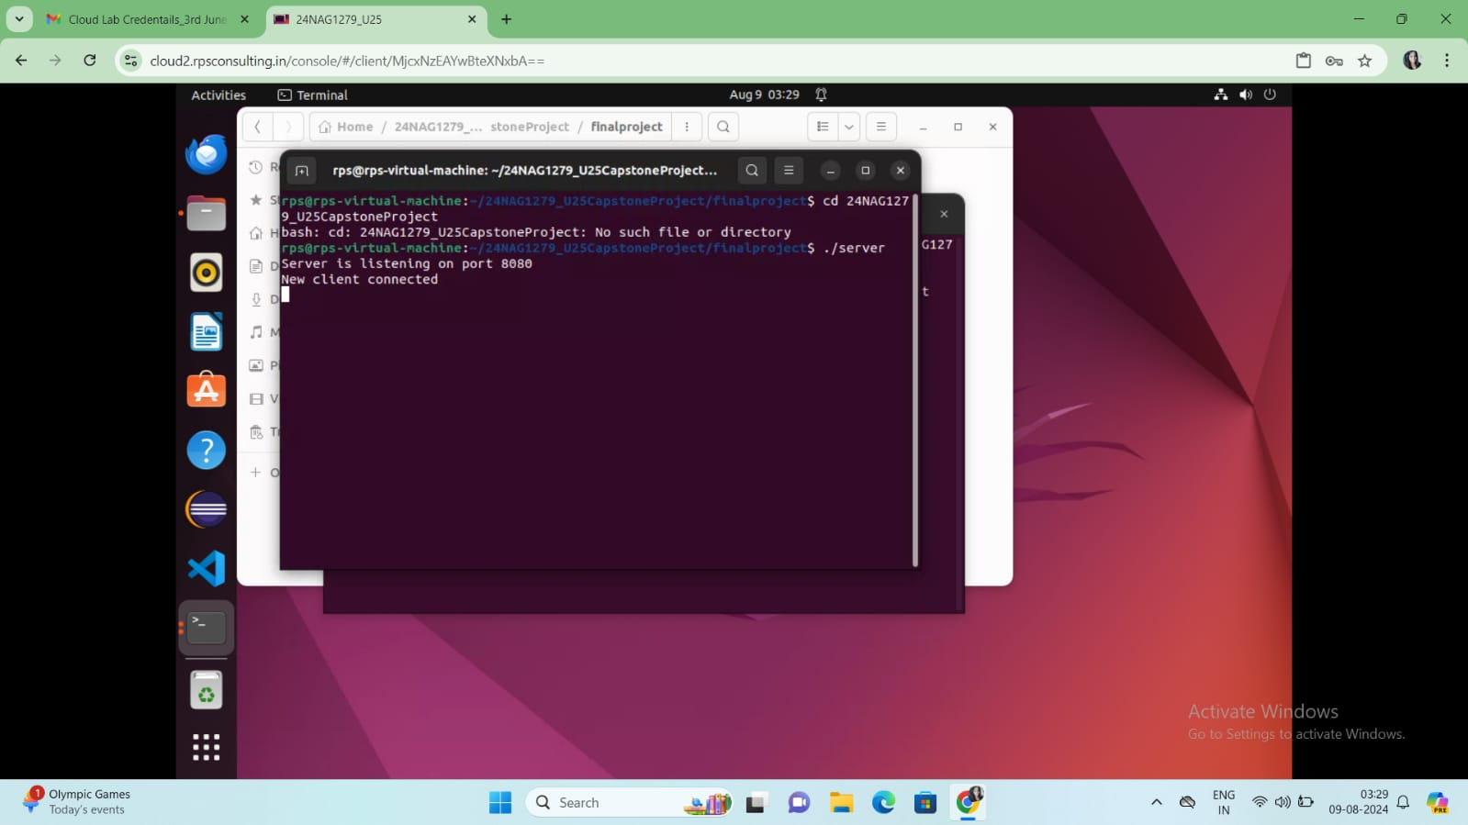

1. CLIENT OUTPUT:

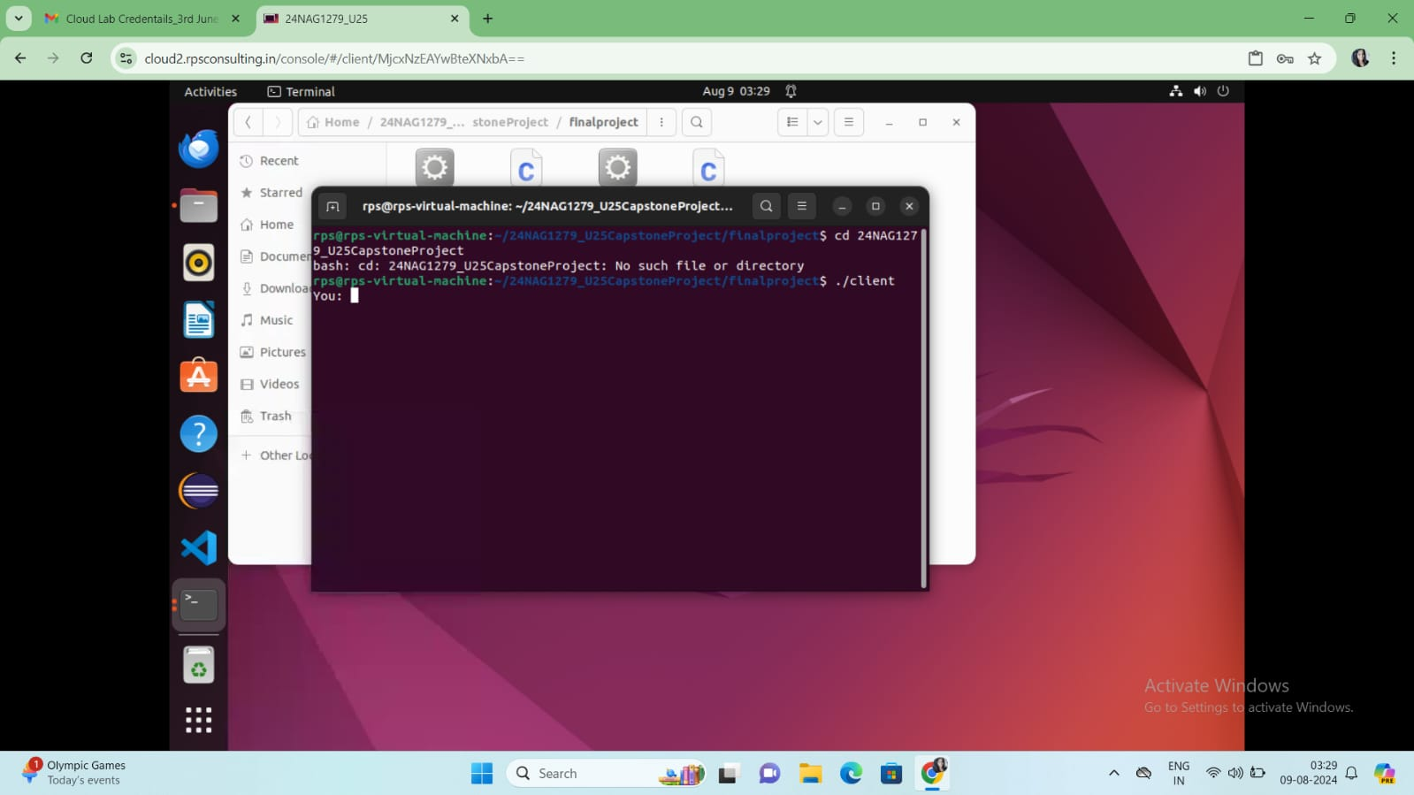

**BY:**

**Himanshee Kumari (09/08/2024)**